Task One – People in Politics
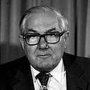
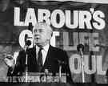
Look at the below photographs of British politicians. You must identify who they are, which party they belonged to and whether or not they were Prime Minister (PM) or Leader of Her Majesty’s Opposition (HMO). Get your family involved in this task – your parents will remember many of these faces, and some of them might be better suited even to your grandparents!

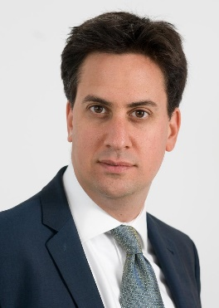
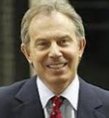
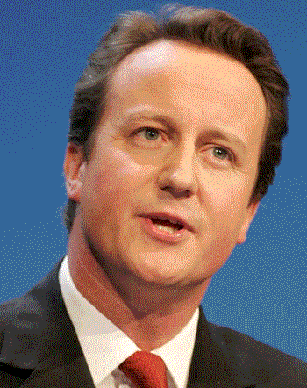

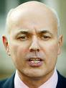
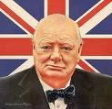

Task Two – News and Elections
Politics is a subject which cannot be unplugged from news and current affairs. Twitter is seen by some to be the future of Politics – it is used by journalists, politicians and politicos alike to share news and information as well as discuss political issues. I would advise that you create yourselves Twitter accounts as soon as possible and follow leaving politicians, bloggers and political journalists. Here are some suggestions:
@SVASocSci (the SVA Social Science Twitter feed)
@Britainelects (for news and updates on all things electoral in the UK)
@BBCNews / @SkyNews (or any other news station of your choice – or even more than one!)
@bbcquestiontime (the UK’s most-watched political talk-show: BBC Question Time)
@POTUS (the president of the United States of America)
@DExEUgov (The Department for Exiting the European Union)
@bbclaurak (Laura Kunssberg – BBC political editor)
@GuidoFawkes (political blogger)
@JohnRentoul (Chief political commentator at The Independent)
Your second task is to keep an eye on these Twitter accounts (as well as wider sources – the news and shows on TV, newspapers and others) over the Summer holidays and make a note of any particularly interesting news that is relevant to Politics in the UK. You may even find some stories which are interesting internationally, particularly if you choose to follow Donald Trump…

Task Three – Read some interesting political books or watch documentaries (preferably both)
Start reading newspapers and magazines such as The Spectator, The Times or The Guardian.
For US Politics, use Real Clear Politics: https://www.realclearpolitics.com/.
Watch political shows like Question Time, Politics Live and This Week.
Watch “Thatcher – A Very British Revolution” on the BBC iPlayer.
Type “UK political documentary” into You Tube. There’s lots to choose from.

